**Experiment – 2.5**

**Student Name: Milan Sharma UID: 23MAI10003**

**Branch: ME – CSE - AIML Section/Group: MAI – 1 (A)**

**Semester: 1st Date of Performance: 18 Oct 2023**

**Subject Name: Python Programming Subject Code: 23 CSH 623**

1. **Aim of the Experiment :**

Write a python program to demonstrate and define a class and object.

Write a python program to create Employable class with some attributes and methods.

Write a python program to implement operator overloading.

Write a python program to demonstrate and define a class and object.

1. **Objective of the Experiment :**
2. To demonstrate and define a class and object.
3. To create Employable class with some attributes and methods.
4. To implement operator overloading.
5. To demonstrate and define a class and object.
6. **Algorithm/ Steps for Experiment**

**Step 1:** Create a python file to perform the python programs.

**Step 2:** Create a function in python.

**Step 3:** Define a class

**Step 4:** Define methods use in class

**Step 5:** Perform operator overloading

**Step 6:** Perform method overriding

**Code for Experiment (Demonstrate and define class and object) :**

class Info:

name = "Milan Sharma"

id = "23MAI10003"

def fun(self):

print("I'm a", self.name)

print("I'm a", self.id)

Student = Info()

Student.fun()

**Result/Output :**

**Capture.PNG**

**Code for Experiment (Employee class with some attributes and method):**

class Employee:

id=0

name=""

gender=""

city=""

salary=0

def setData(self,id,name,gender,city,salary):

self.id=id

self.name = name

self.gender = gender

self.city = city

self.salary = salary

def showData(self):

print("Id\t:",self.id)

print("Name\t:", self.name)

print("Gender\t:", self.gender)

print("City\t:", self.city)

print("Salary\t:", self.salary)

def main():

#Employee Object

emp=Employee()

emp.setData(10003,'Milan Sharma','Male','Mathura',5500000)

emp.showData()

if __name__=="__main__":

main()

**Result/Output :**

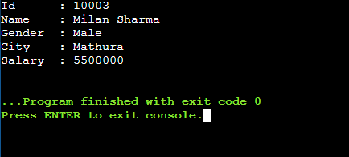

**Code for Experiment (Operator Overloading):**

class Point:

def __init__(self, x=0, y=0):

self.x = x

self.y = y

def __str__(self):

return "({0},{1})".format(self.x, self.y)

def __add__(self, other):

x = self.x + other.x

y = self.y + other.y

return Point(x, y)

p1 = Point(1, 2)

p2 = Point(2, 3)

print ("P1 :",p1)

print ("P2 :",p2)

print("After overloading :",p1+p2)

**Result/Output :**

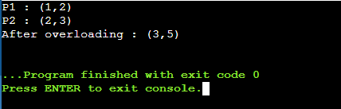

**Code for Experiment (Employee class with some attributes and method):**

class Animal:

# properties

multicellular = True

# Eukaryotic means Cells with Nucleus

eukaryotic = True

# function breathe

def breathe(self):

print("I breathe oxygen.")

# function feed

def feed(self):

print("I eat food.")

class Herbivorous(Animal):

# function feed

def feed(self):

print("I eat only plants. I am vegetarian.")

herbi = Herbivorous()

herbi.feed()

# calling some other function

herbi.breathe()

**Result/Output :**

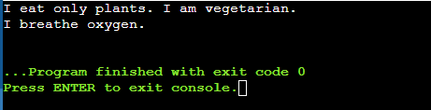

**Learning outcomes (What I have learnt):**

1. I learnt about the python language and its basic syntax.
2. I learnt about functions in python.
3. I learnt about class and object.
4. I learnt about method overriding and operator overloading.

**Evaluation Grid (To be created as per the SOP and Assessment guidelines by the faculty):**

|  |  |  |  |
| --- | --- | --- | --- |
| **Sr. No.** | **Parameters** | **Maximum Marks** | **Marks Obtained** |
| **1.** | **Student Performance**  **(Conduct of experiment)**  **Objectives/Outcomes.** | 12 |  |
| **2.** | **Viva Voce** | 10 |  |
| **3.** | **Submission of Work Sheet**  **(Record)** | 8 |  |